**Topic: Low Molecular Weight Gelators (LMWGs) in Drug Delivery**

**Summary:**

LMWGs are small organic molecules that self-assemble into gel networks. In drug delivery, they are used to encapsulate drugs, control release rates, and enhance biocompatibility. The field has seen growing interest since 2015, particularly in peptide-based gelators.

**Research Rabbit**

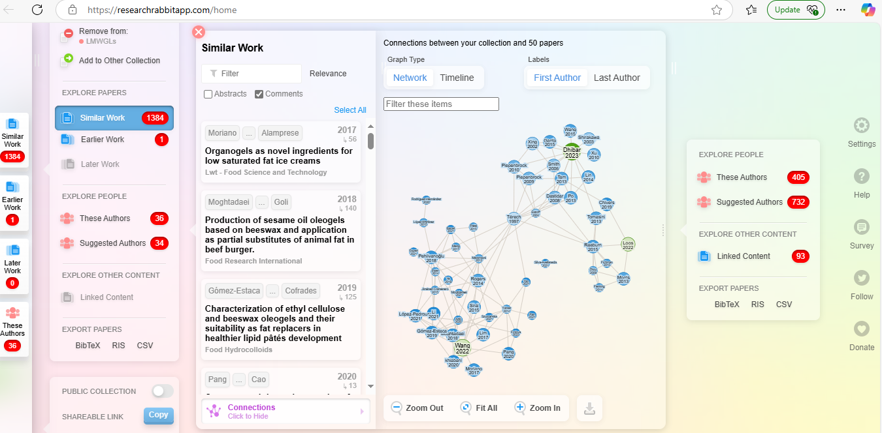

**Elicit**

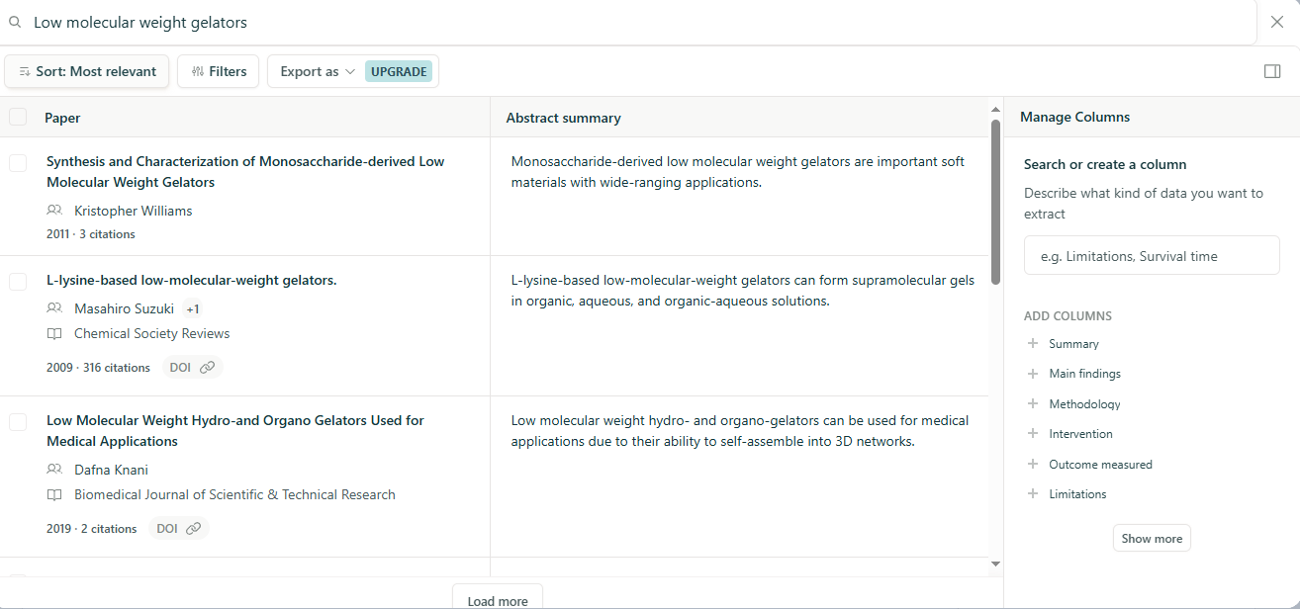

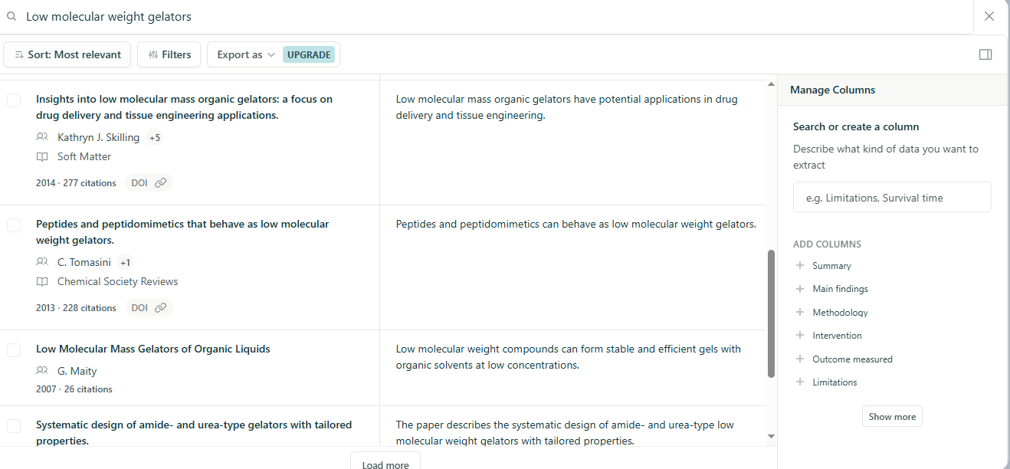

**Perplexity**

Recent studies on low-molecular-weight gelators (LMWGs) in drug delivery highlight their promising role as versatile and tunable drug carriers, particularly in hydrogel form, for controlled and targeted release applications.

## Key Advances in LMWGs for Drug Delivery

**1. Modular and Tunable Drug Release:**

* LMWGs can form hydrogels that allow for precise control over drug release mechanisms. For example, a reaction-coupled LMWG system demonstrated tunable doxorubicin release by altering the timing of gelator and drug component assembly, switching between covalent and noncovalent drug binding. This switch modulates the release profile from faster Fickian diffusion to slower semi-Fickian release, enabling sustained drug delivery suitable for cancer therapy (MCF-7 breast cancer cells)[4](https://pubs.acs.org/doi/10.1021/acs.biomac.2c01197).

**2. Stimuli-Responsive Delivery:**

* LMWG-based systems can be engineered to respond to endogenous triggers such as pH, redox conditions, enzymes, and reactive oxygen species, or exogenous triggers like light, temperature, magnetic fields, and ultrasound. These stimuli-responsive properties enhance tumor-specific delivery and controlled release, improving therapeutic efficacy and reducing side effects[1](https://pmc.ncbi.nlm.nih.gov/articles/PMC6900554/)[5](https://www.frontiersin.org/articles/10.3389/fmats.2022.845700/full).

**3. Biocompatibility and Versatility:**

* Natural-drug-based LMWGs and organogels have been developed as biocompatible carriers for hydrophobic and hydrophilic drugs, showing promise in sustained release and chemotherapy applications. For instance, paclitaxel-loaded organogel nano-dispersions demonstrated significant anti-cancer effects in vitro and in vivo[5](https://www.frontiersin.org/articles/10.3389/fmats.2022.845700/full)[2](https://pmc.ncbi.nlm.nih.gov/articles/PMC8395818/).

**4. Application in Wound Healing:**

* LMWG hydrogels have been used as carriers for therapeutic metal ions, such as copper salts, to promote wound healing in animal models, indicating their potential beyond cancer therapy into regenerative medicine[8](https://www.mdpi.com/1999-4923/15/4/1119).

**5. Ease of Preparation and Functionalization:**

* The modularity of LMWGs allows facile preparation from inexpensive components under physiological conditions, enabling in situ gelation and drug loading. This adaptability supports the design of personalized drug delivery systems with tunable mechanical properties and release kinetics[4](https://pubs.acs.org/doi/10.1021/acs.biomac.2c01197).

## Summary

Low-molecular-weight gelators are emerging as a versatile platform in drug delivery due to their modular design, stimuli-responsive behavior, and biocompatibility. Recent studies focus on reaction-coupled self-assembly for controlled drug release, co-delivery strategies, and applications in cancer therapy and wound healing. These advances position LMWGs as promising candidates for next-generation therapeutic delivery systems with improved efficacy and patient compliance[1](https://pmc.ncbi.nlm.nih.gov/articles/PMC6900554/)[2](https://pmc.ncbi.nlm.nih.gov/articles/PMC8395818/)[4](https://pubs.acs.org/doi/10.1021/acs.biomac.2c01197)[5](https://www.frontiersin.org/articles/10.3389/fmats.2022.845700/full)[8](https://www.mdpi.com/1999-4923/15/4/1119).

### Citations:

1. <https://pmc.ncbi.nlm.nih.gov/articles/PMC6900554/>
2. <https://pmc.ncbi.nlm.nih.gov/articles/PMC8395818/>
3. <https://pubs.rsc.org/en/content/articlehtml/2024/sm/d3sm01301d>
4. <https://pubs.acs.org/doi/10.1021/acs.biomac.2c01197>
5. <https://www.frontiersin.org/articles/10.3389/fmats.2022.845700/full>
6. <https://www.sciencedirect.com/science/article/pii/S2090123224001267>
7. <https://www.sciencedirect.com/science/article/pii/S258996512400103X>
8. <https://www.mdpi.com/1999-4923/15/4/1119>

Answer from Perplexity: <https://www.perplexity.ai/search/recent-studies-on-lmwgs-in-dru-vA4ntnIrTDSJg76NOX46Ag?utm_source=copy_output>

